 EngiNEEring

Engineering is the designing, testing and building of machines, structures and processes using math and science. Engineering is a discipline dedicated to problem solving. Our built environment and infrastructure, the devices we use to communicate, the processes that manufacture our medicines, have all been designed, assembled or managed by an engineer.

You will find engineers working on advanced prosthetics, creating new materials, investigating engine efficiency and alternative fuels, constructing bridges or developing clean water systems. From satellites to cell membranes engineers use maths and science to achieve extraordinary things and find solutions to some of the world's most complex challenges.

COURses

* Computer engineering
* Electrical engineering
* Automobile engineering
* Mechanical engineering
* Chemical engineering
* Robotics
* Civil engineering
* Aerospace engineering
* Biomedical engineering
* Petroleum engineering
* Mining engineering
* Structural engineering
* Power engineering

What is the study of engineering?

Many students deciding on which academic major they want to pursue often ask themselves “What is engineering?” Engineering is a section of technology and science that focuses on the design of engines, machines, structures and electrical systems. Engineering is deeply rooted in mathematics principles.



speciaiizations of engineering

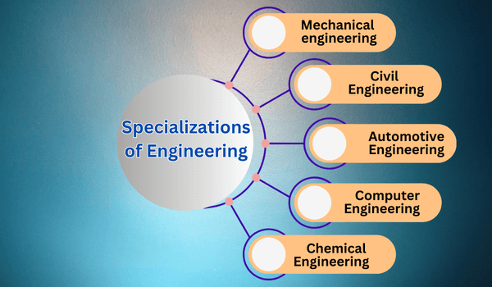

10 engineering courses that are currently in demand

For higher education abroad

computer engineering

Computer engineering (CoE or CpE) is a branch of computer science and electronic engineering that integrates several fields of computer science and electronic engineering required to develop computer hardware and software.



Electrical engineering

 Electrical engineering is an engineering discipline concerned with the study, design, and application of equipment, devices, and systems hich use electricity, electronics, and electromagnetism.